

Put your logo code here

**Server Backup**

**The multi-tool for all servers…**

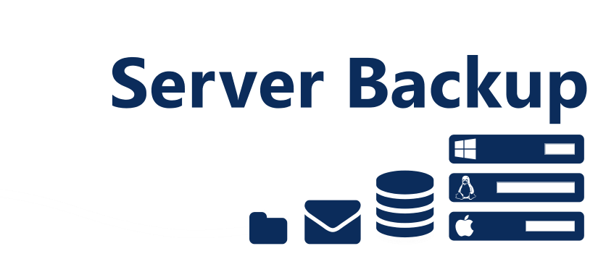

100GB all-in monthly cost: (per license)

**£39.50** (+VAT)

Includes 1 x license (can be installed on multiple servers), 100GB (uncompressed) & unlimited bandwidth. (Extra 20GB chunks @ £1.80 ea.)

*Responsible for a server? Want to selectively backup OS, DB & mail?*

***Get the right tool for the job!***  Our **Server Backup** is a robust, efficient and versatile power tool; from entire bare-metal restore down to single mailbox recovery. *Single license can be installed on multiple servers!*

▪ Restore files/shares

 Bare-metal restore (no OS)

 Restore databases

Microsoft SQL

MySQL & Oracle

→ Restore email

Microsoft Exchange

Lotus Notes

 Microsoft servers

 Mac servers

 Linux/IBM servers

 CRC check & full encryption

✴ Customisable

Offline copies

Point-in-time restore

Schedules, reports & more...

Put your creds here



***The small print:*** 1 month rolling contract. Data encryption chosen by you – we do not retain passwords, so if you forget your password we will be unable to decrypt your data on your behalf.

Put your QR code here

✶ www.{your domain}

 0800 {your phone}

*Ask for {name} {mobile}*

Sign up and enjoy using the service *today*!